EXPERIMENT 09
ROLL : 240701437 NAME : Rohith Nikethan P

Aim:
The goal of this experiment was to build a user input form that checks the validity of details such as email, phone number, and password. The form should give immediate feedback when incorrect data is entered, using HTML, CSS, and JavaScript.
Objectives:
• To understand the structure of HTML forms
• To apply CSS styling for better UI design
• To implement client-side validation using JavaScript
• To validate email, phone number, and password
• To display real-time error messages
Tools Required:
• Text Editor (VS Code)
• Web Browser (Chrome )
• JavaScript

Procedure:
Step 1: Creating the HTML Form
Description:
A basic HTML form is created with input fields like Name, Email, Phone Number, andPassword.
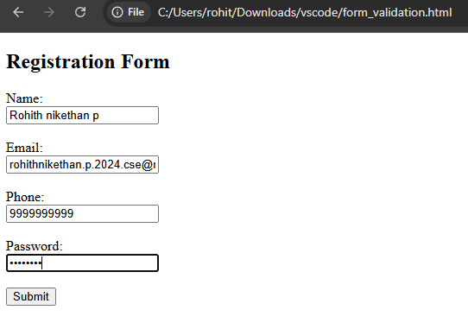

Explanation:
The form contains basic input fields. Each field allows the user to enter required details. No validation or styling is applied at this stage.

Step 2: Styling using CSS
Description:
CSS is used to improve the appearance of the form and make it user-friendly.
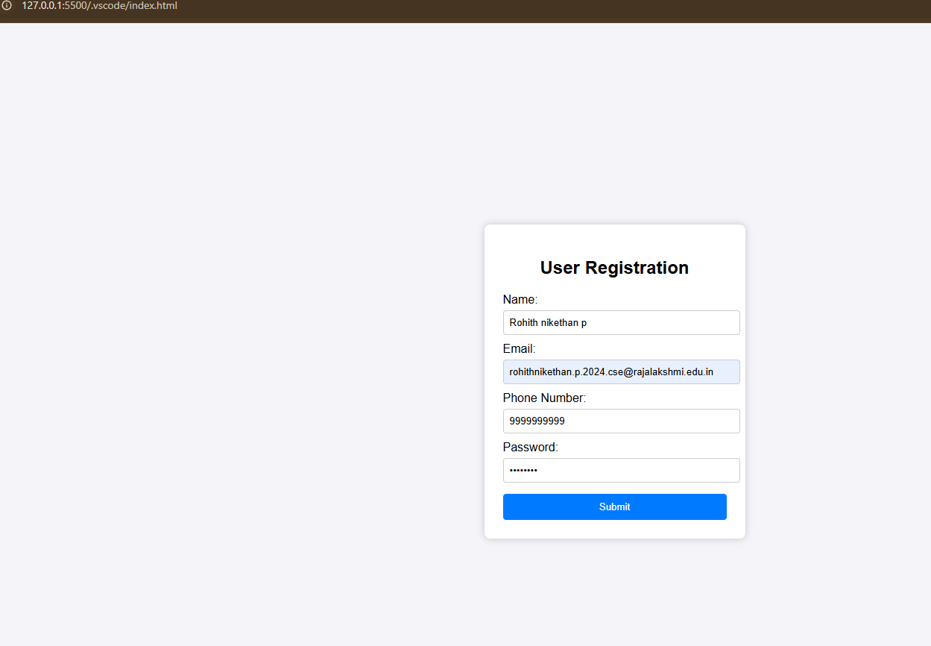

Explanation:
The form is styled with proper spacing, background color, and alignment. This enhances user experience and gives a professional look.

Step 3: Adding JavaScript Validation
Description:
JavaScript is used to validate user inputs before submission.


Explanation:
Validation checks ensure:
• Email follows correct format
• Phone number contains 10 digits
• Password has minimum length
Error messages are displayed when invalid input is entered.
Result:
The input form was successfully created with validation for email, phone number, and password. Error messages are displayed correctly, ensuring valid user input.

Conclusion:
This experiment helped in understanding how to design interactive forms using HTML, CSS, and JavaScript. Validation improves data accuracy and enhances user experience.

